**Documentation of the FrontPage design**

**General information:**

Background color: █ 163E3D

Text color: █ 000000

Highlighted text color : █ F50A0A

Date and time underlining in links. █ F5A200

Text color in green background: ☐ FFFFFF

Borders of the links and navigation bar: █ 7BC7AB

Colors of the icons in navigation bar: ☐ FFFFFF

Main font: Open Sans

**Navigation bar:**

* The icon in the upper left corner opens the navigation menu.
* In the middle is the Geocache.fi logo
* The icon in the upper right corner opens the login/registration page or, if you are already logged in, a view of your account information.

**Hero image:**

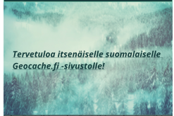

Web address of the hero image : <https://pixabay.com/illustrations/forest-winter-forest-snow-landscape-4693526/>

* Free to use under the Content License
* Attribution optional not required.
* The catchphrase of the image can be varied.

**Add banner:**

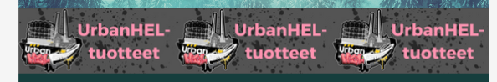

* 3 places are reserved for advertising banners across the width of the screen, and if there are fewer ads, the empty places are filled with the selected advertising banner (in this case, UrbanHEL products)
* In the case of two ads, the idea is to have the same ad on both sides and a different one in the middle.
* If there are more than three ads, the ads are split into two lines.

**Body of the website:**

**Links:**

Cache:

* Cache icon, several different types. By pressing the icon, only the logs of that cache can be selected for display.
* Time and date, if the cache was added less than an hour ago, the minutes from when the cache was added are displayed highlighted in red. In caches older than this, the date and time are displayed.
* The name of the cache also serves as a link to the cache's own page with more detailed information.
* The distance of the cache from the starting point defined by the user. If the cache is closer than the limit defined by the user, the distance is highlighted in red.
* The municipality in which the cache is located.
* On the front page, the links are divided into two different categories

 The latest geocaches.

 Upcoming events

Show more:

 Selecting this will show 5 more caches/events each time you press the button.

Logo and a link to the www.geocaching.com site

Web address of the logo <https://www.geocache.fi/images/Geocaching_API_Logo_vCOMP2_090716_LRG.png>

Footer

Attached in the document are the pictures from the front page in whole size and in screen size

